**Objective:**

Implementing a microservice using the Python Flask framework on an Ubuntu virtual machine to serve a machine learning prediction model.

**Machine Learning Task:**

To build a machine learning model to predict whether the cancer type is Malignant or Benign.

To create a Docker image containing everything needed to run the application: the application code, libraries, tools, dependencies, and other files and to use the image to run the application in containers.

**Dataset:**

For this case study we are going to work with the following dataset: <https://archive.ics.uci.edu/ml/datasets/Breast+Cancer+Wisconsin+(Diagnostic)>

**Steps to be performed:**

1. Host a Ubuntu Virtual Machine using Oracle VM Virtual Box.

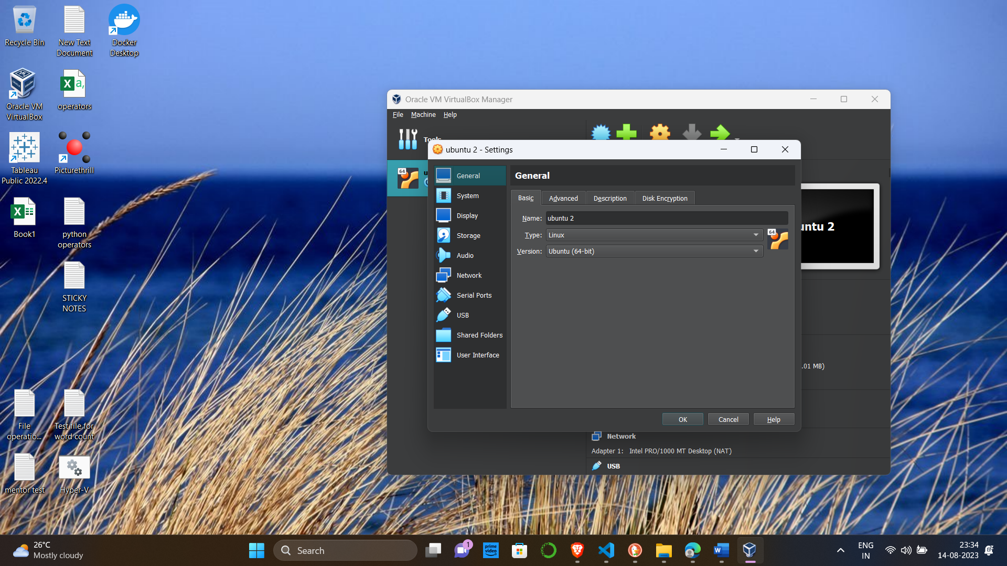



2. Set up Visual Studio code on Ubuntu VM.

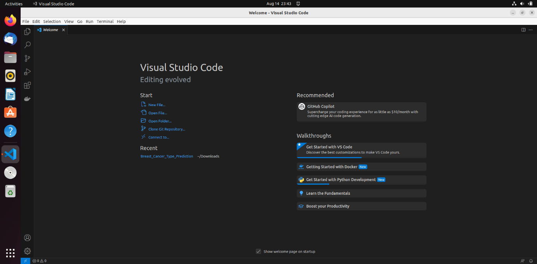

3. Set up Python. 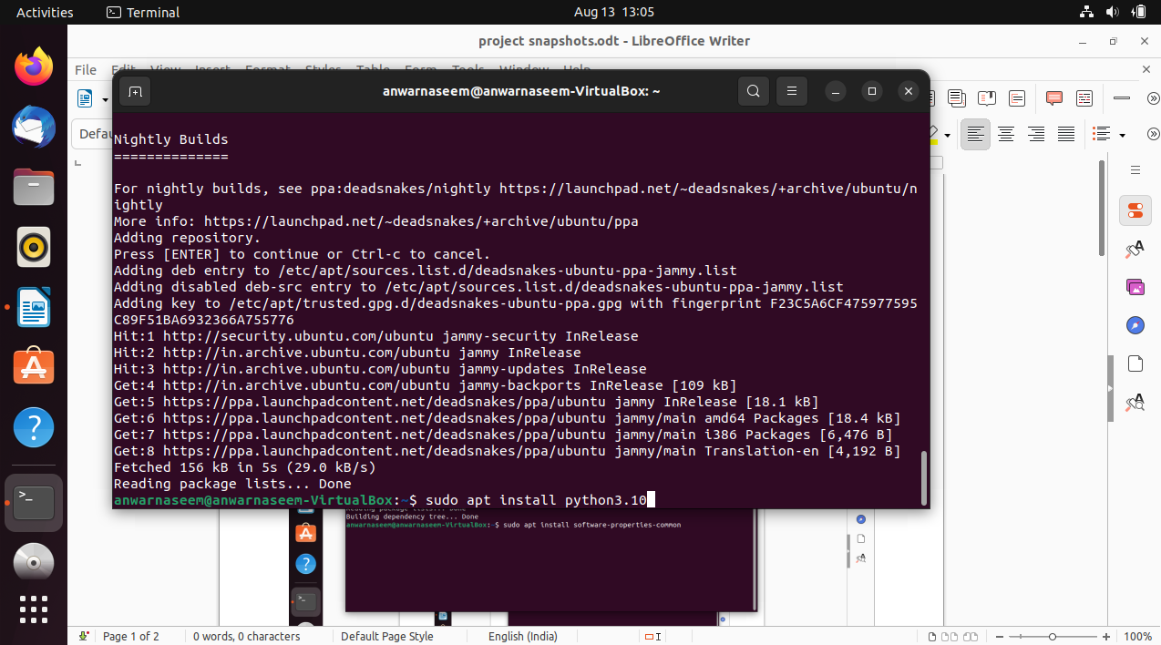

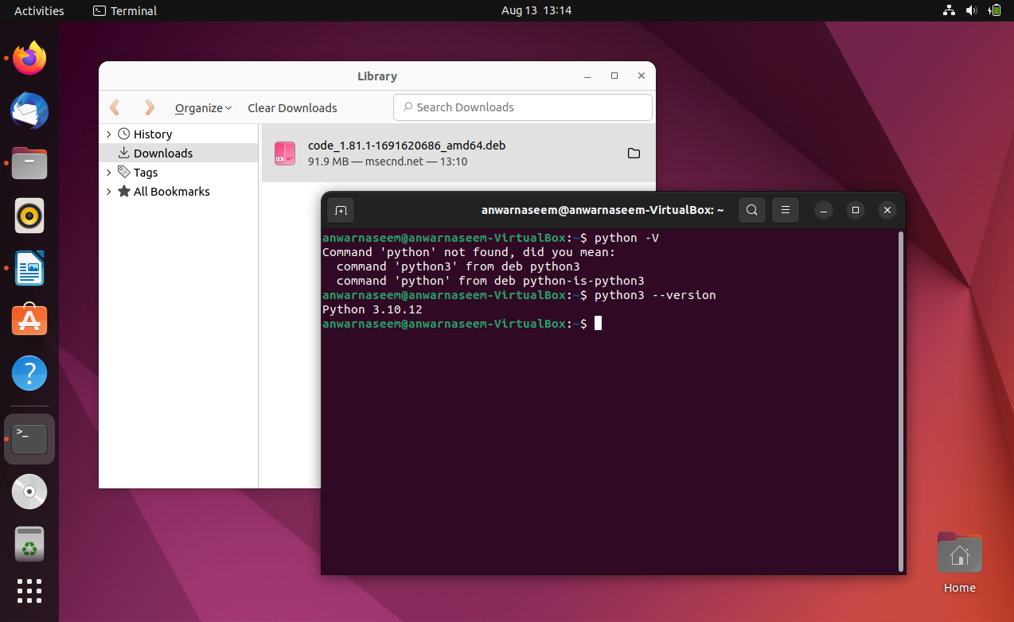

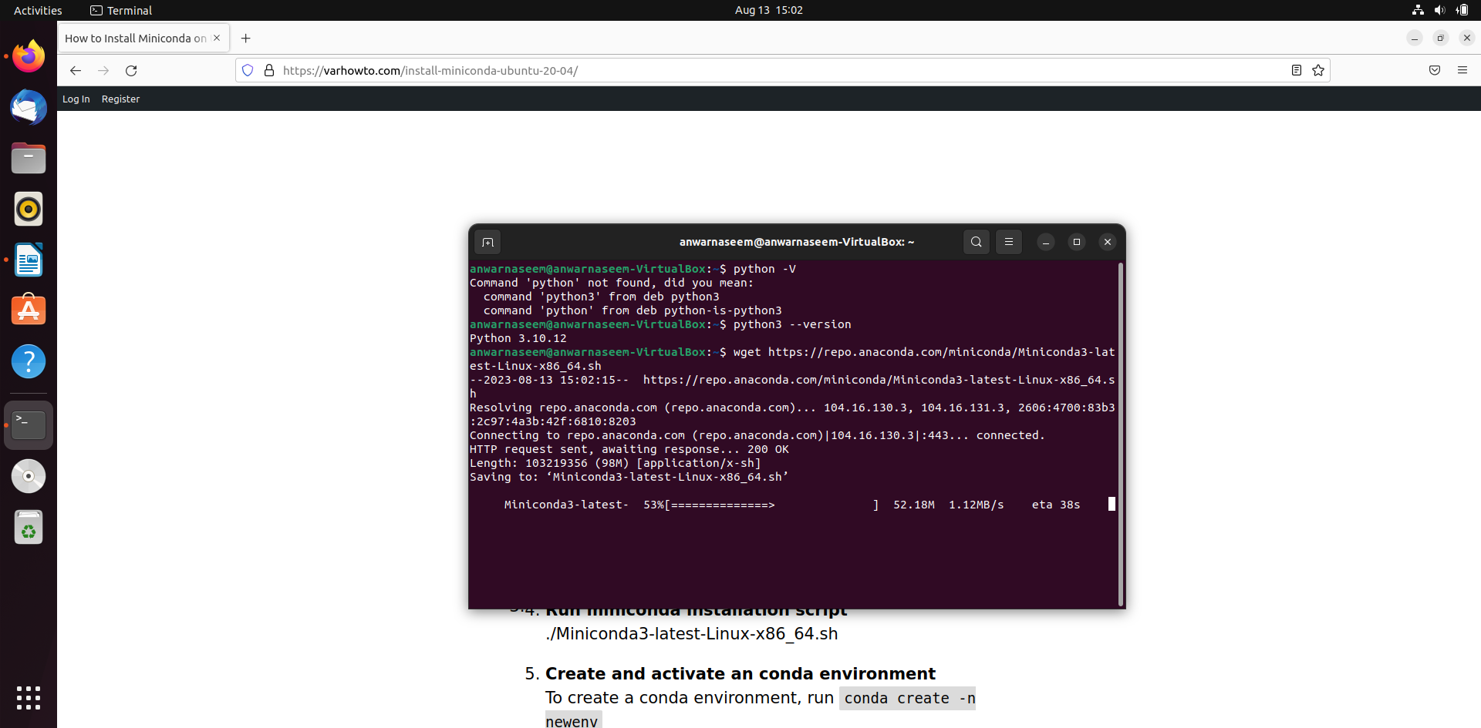

4. Clone this Github repository https://github.com/Vikas098766/Microservices.git (1 mark) 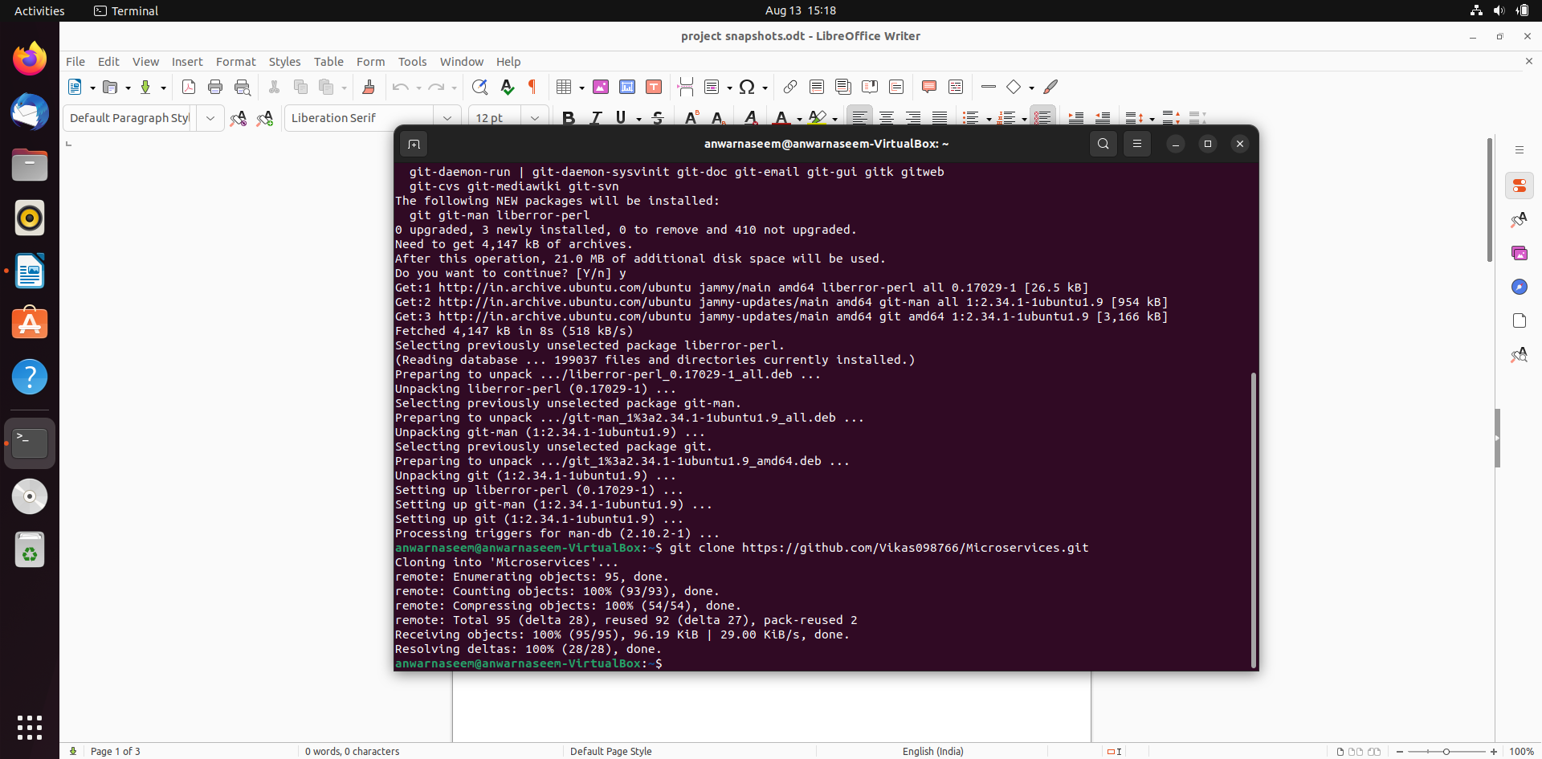

5. Create a Virtual Environment.

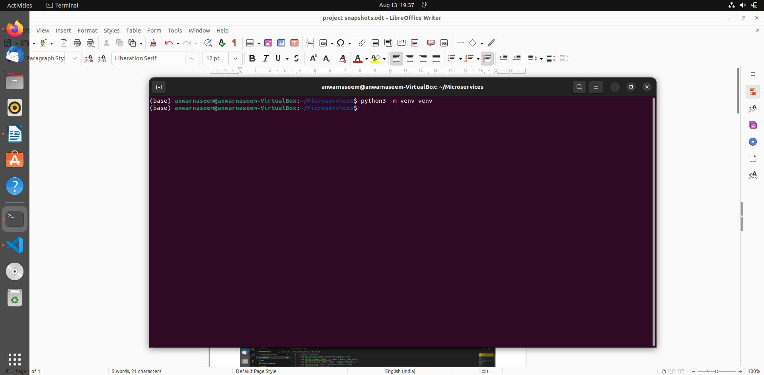

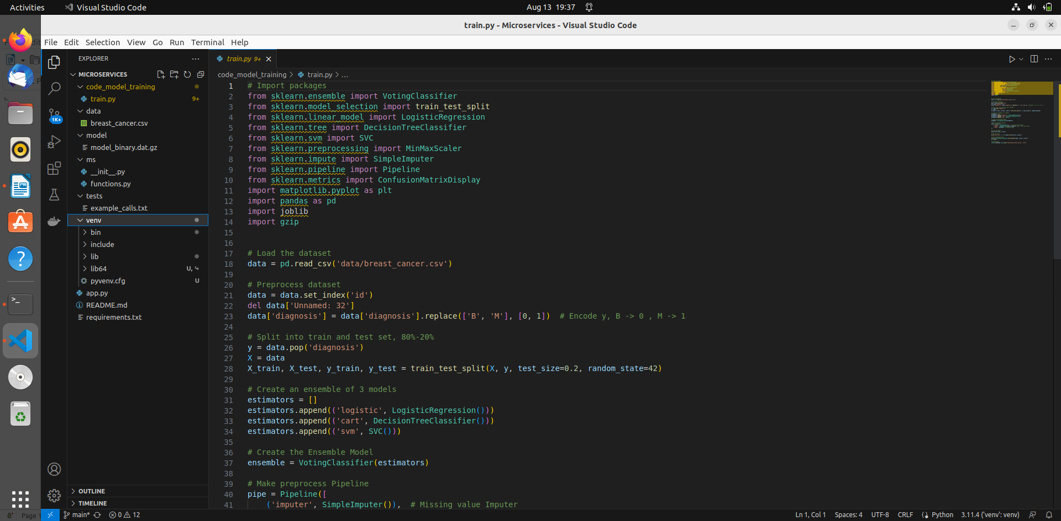

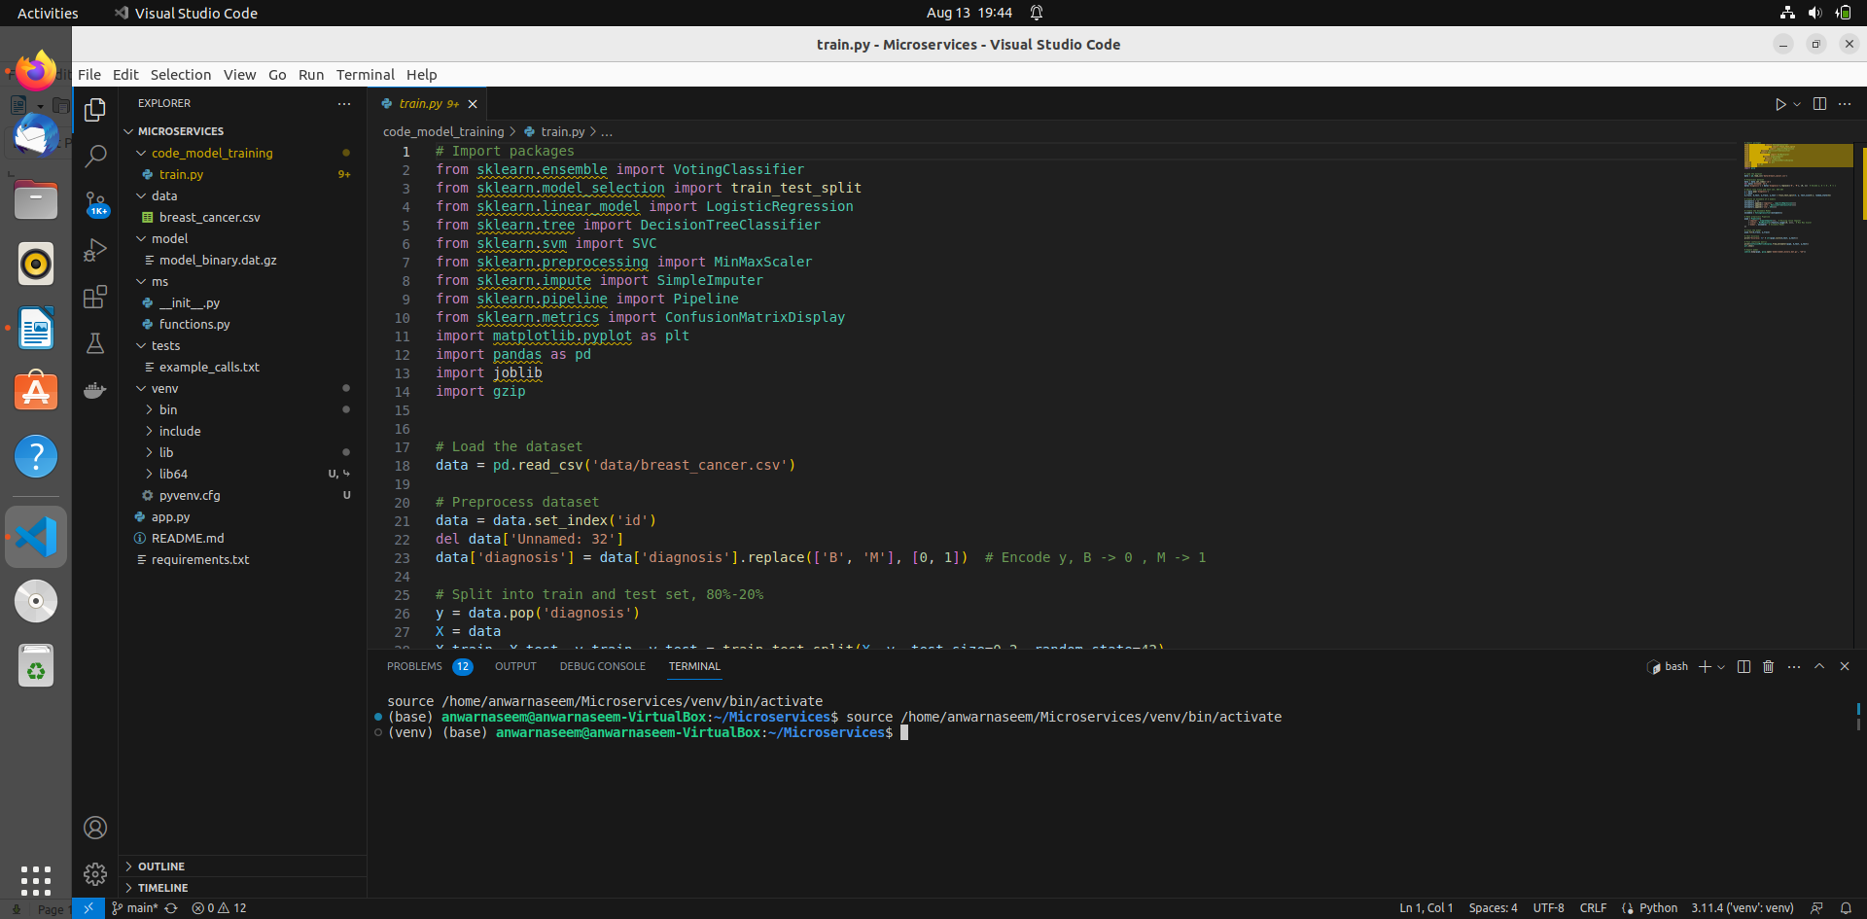

6. Install the dependencies from requirements.txt file.

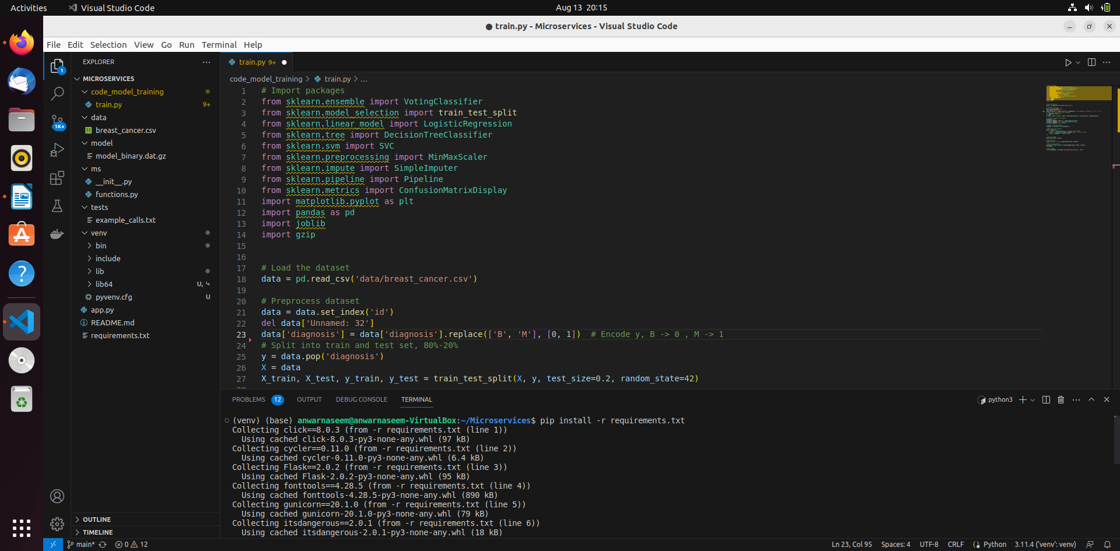

7. Train and save the model. 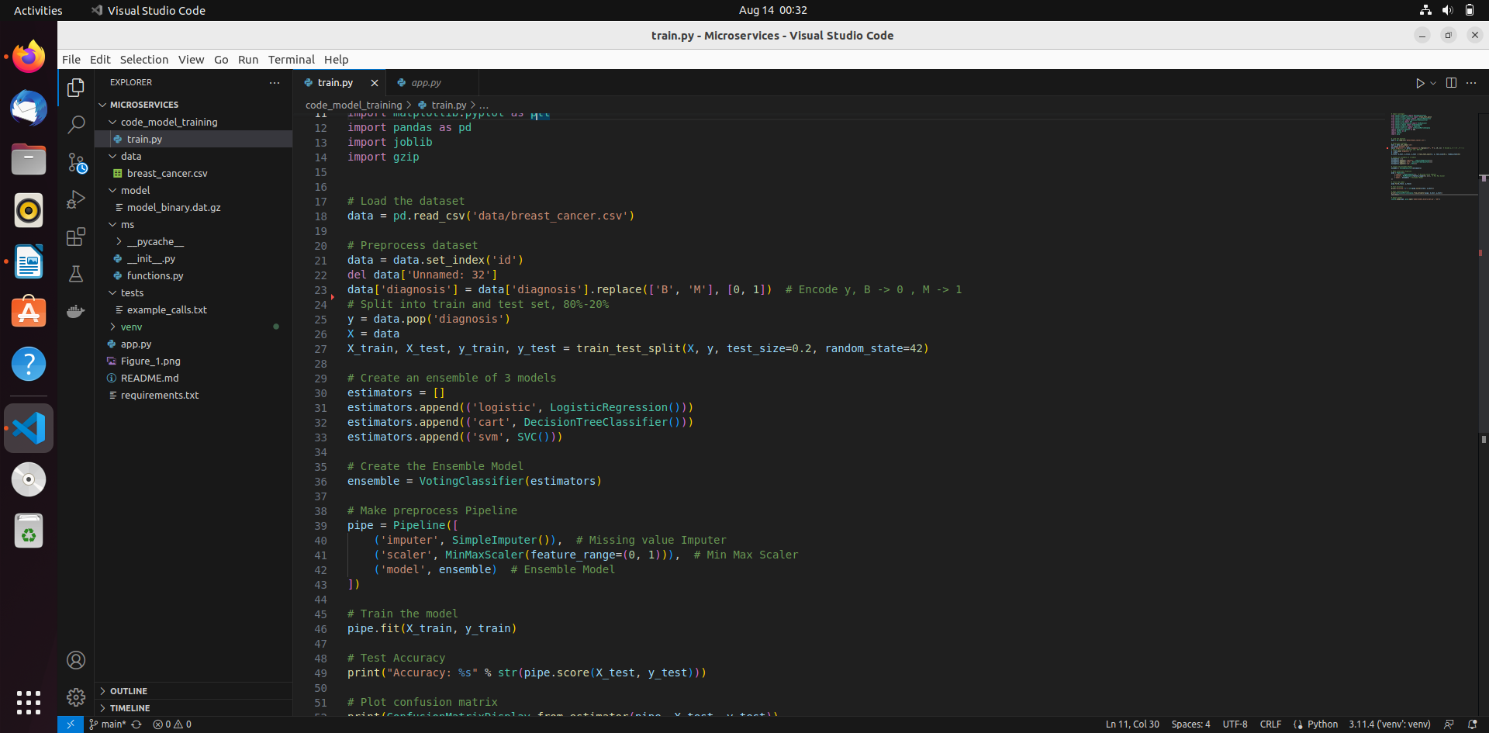

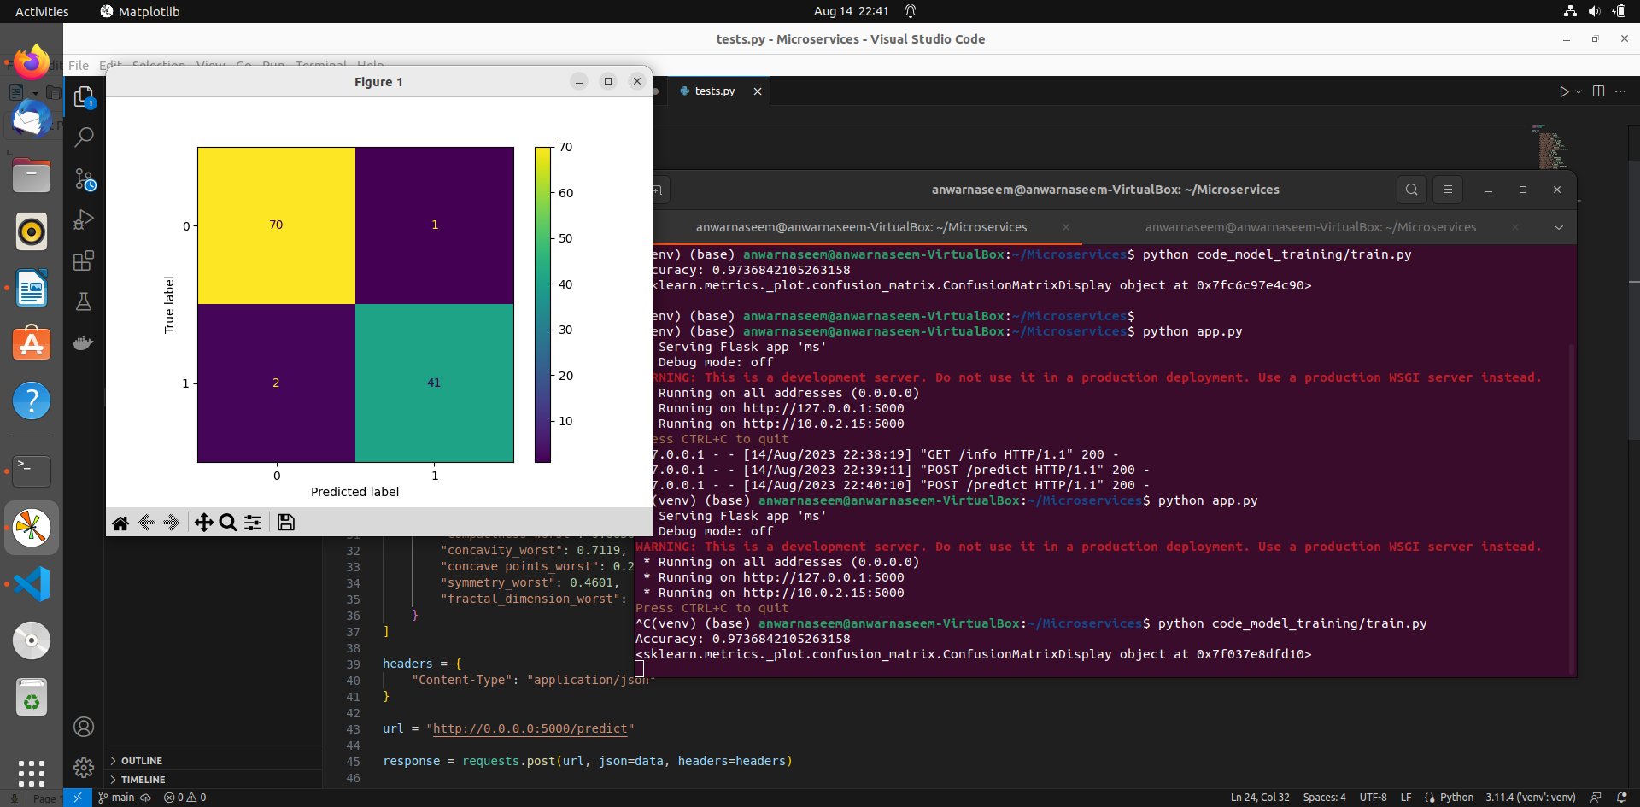

8. Test the Flask web application. 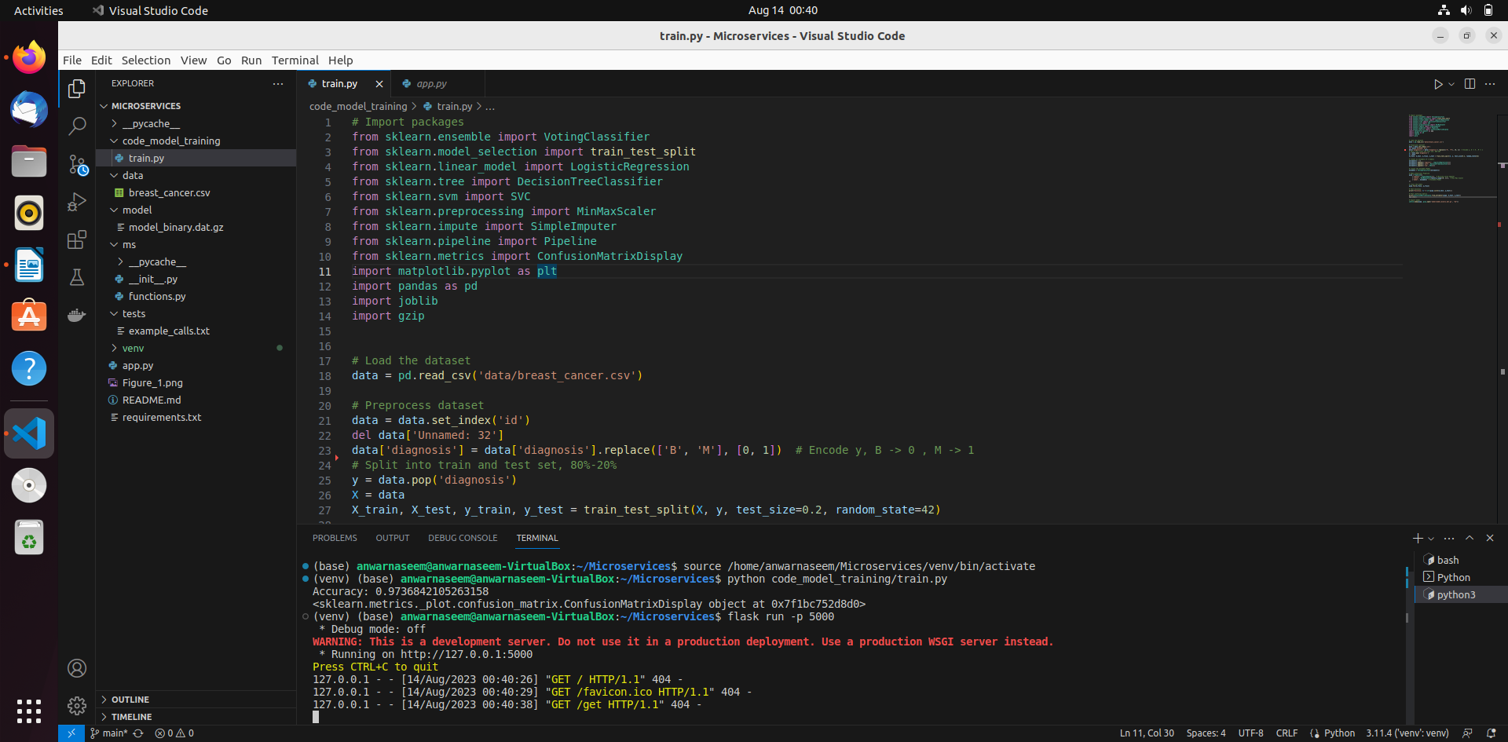

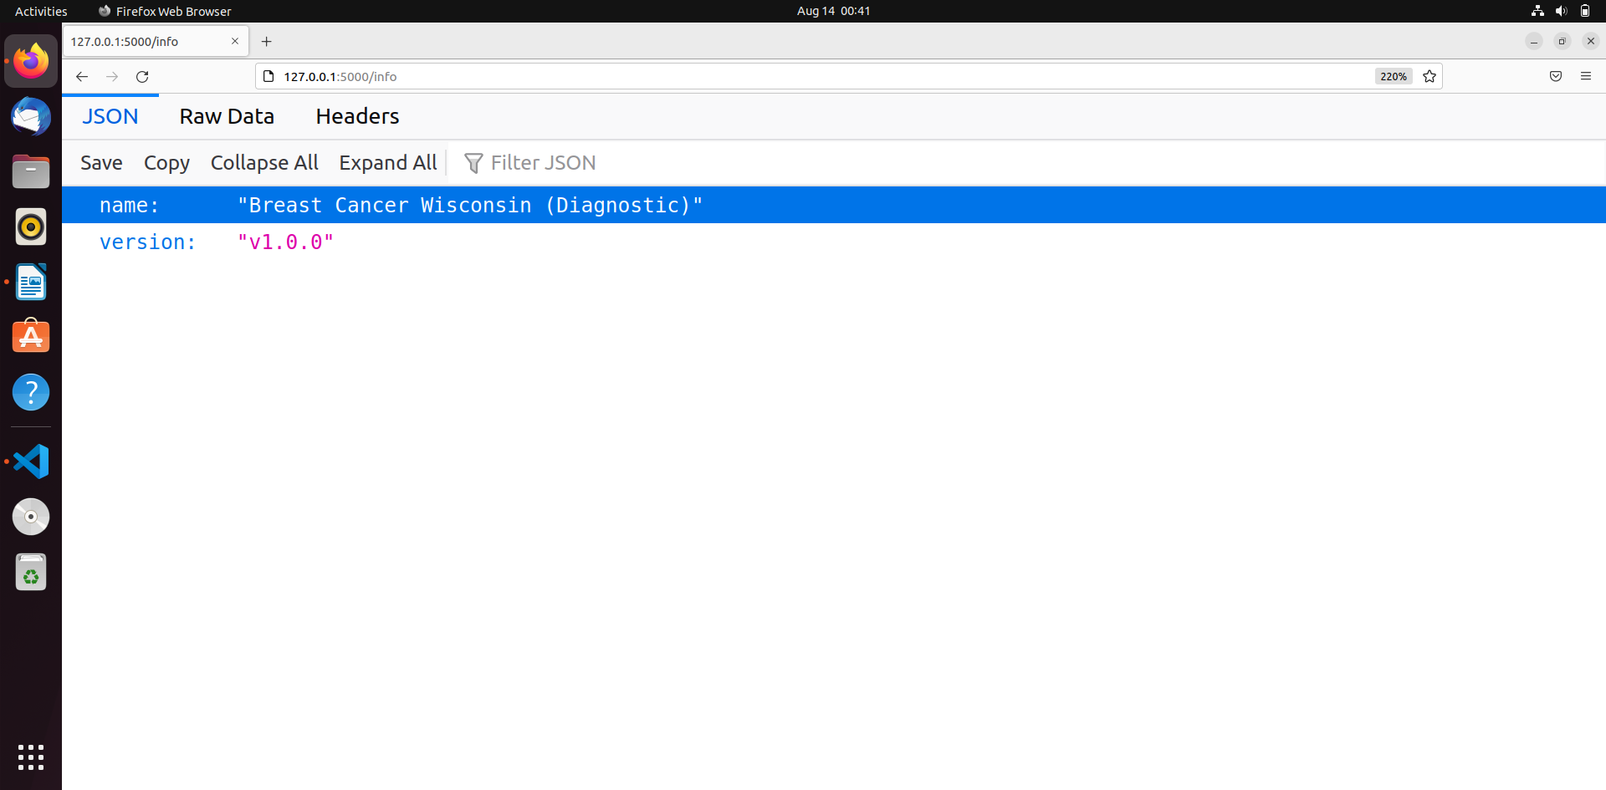

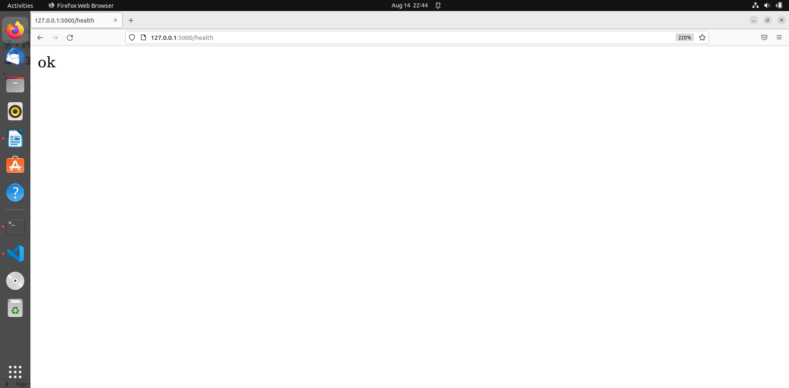

9. Test the application and make predictions using the example calls available in the folder /tests.

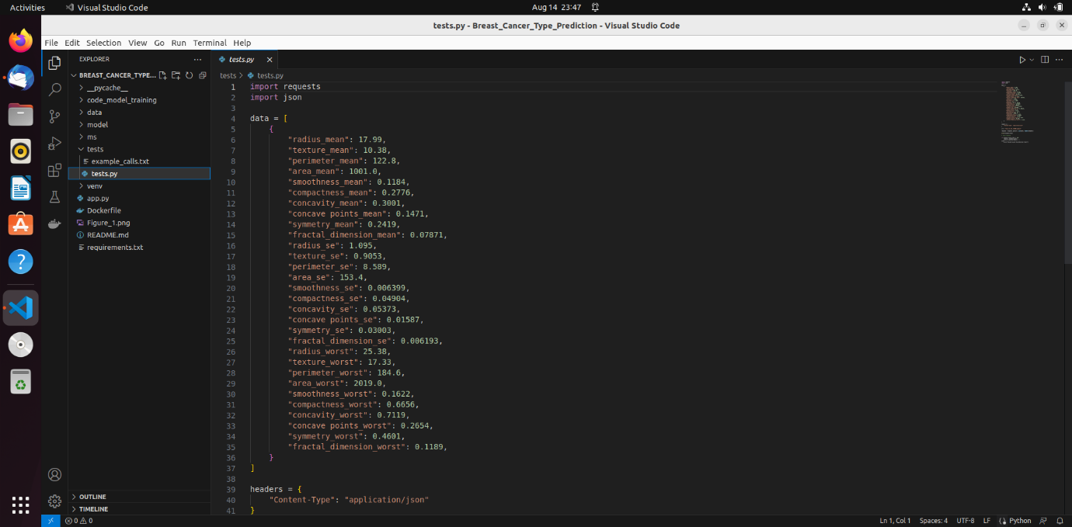

10.Create a docker image containing everything needed to run the application.

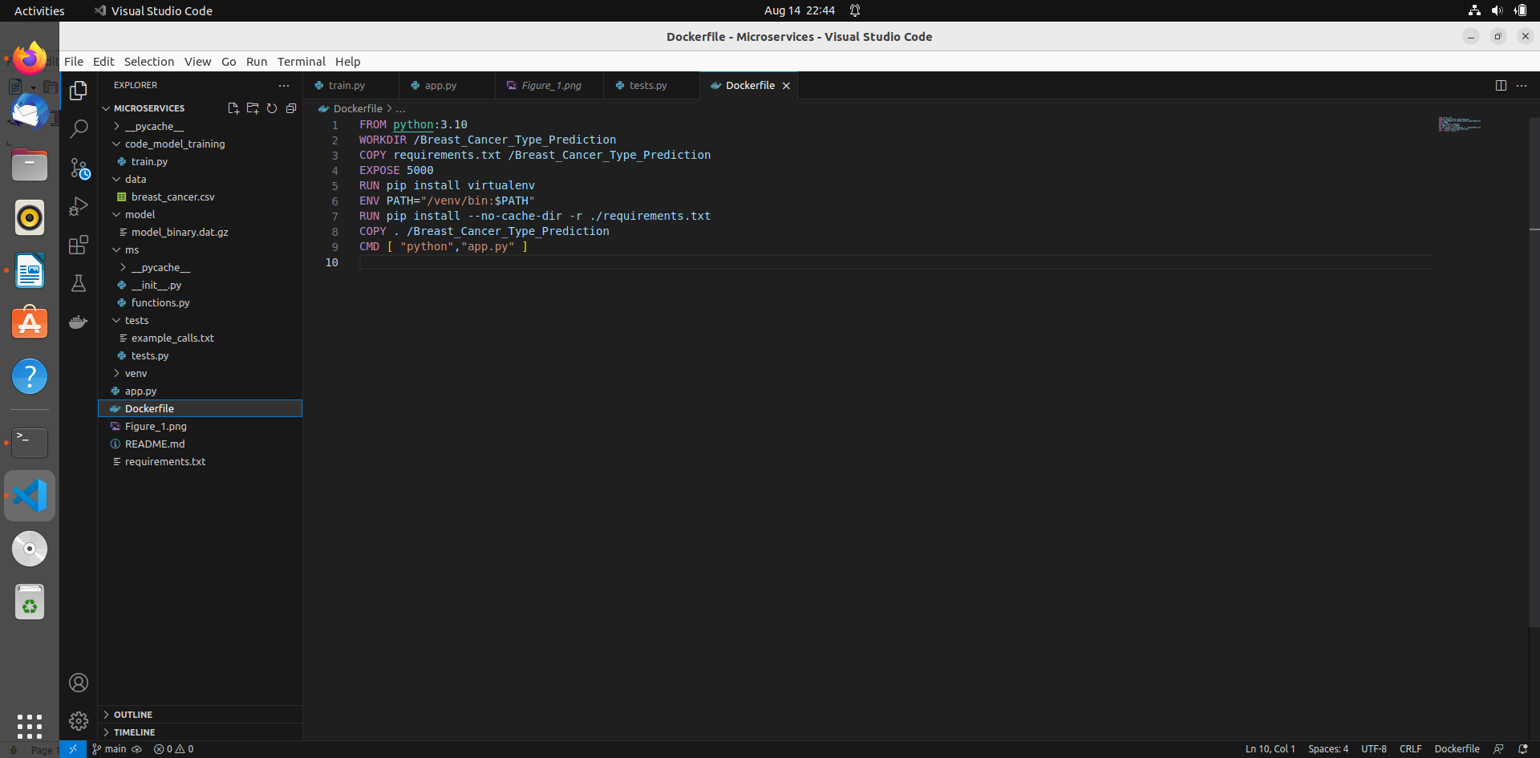

11.Run the containerized application as a prediction service and test it locally by passing some example calls and get the prediction.

